|  |  |
| --- | --- |
| **Ex. No: 3** | **Form Making and Validation using JavaScript** |
| **27.07.2023** |

**Aim:**

To create a Form with usual form elements in JavaScript including the Alert(), Confirm(), and Response() functions. Additionally, validate the form elements.

**Algorithm:**

1. Create HTML and CSS file
2. Setup JavaScript in the HTML file
3. Access the form elements
4. Setup a validation logic
5. Use the Alert(), confirm() and response() functions for validation
6. Display validation results

**Program:**

HTML

<!DOCTYPE html>

<html>

<head>

<title>Form with JavaScript Functions</title>

<style>

.error {

color: red;

}

.padit {

padding: 10px;

}

</style>

</head>

<body>

<div style="display:flex; background-color: aqua; justify-content: center; max-width:750px ;

max-height:750px; margin-left: auto; margin-right: auto; margin-top: 100px; margin-bottom: auto;">

<form id="myForm">

<div class="padit">

<label for="name">Name:</label>

<input type="text" id="name" name="name" required>

<span id="nameError" class="error"></span>

</div>

<div class="padit">

<label for="email">Email:</label>

<input type="email" id="email" name="email" required>

<span id="emailError" class="error"></span>

</div>

<div class="padit">

<label for="message">Message:</label>

<textarea id="message" name="message" rows="4" cols="17" required></textarea>

<span id="messageError" class="error"></span>

</div>

<div class="padit">

<button type="submit">Submit</button>

</div>

</form>

</div>

<!-- run validation on #id "myForm" -->

<script src="index.js"></script>

</body>

</html>

Javascript

document.getElementById('myForm').addEventListener('submit', function(event)

{

const name = document.getElementById('name').value.trim();

const email = document.getElementById('email').value.trim();

const message = document.getElementById('message').value.trim();

const nameError = document.getElementById('nameError');

const emailError = document.getElementById('emailError');

const messageError = document.getElementById('messageError');

let isValid = true;

function isValidEmail(email) {

const emailRegex = /^[^\s@]+@[^\s@]+\.[^\s@]+\.[^\s@]+$/;

return emailRegex.test(email);

}

if (name === '') {

nameError.textContent = 'Name is required';

isValid = false;

} else {

nameError.textContent = '';

}

if (email === '') {

emailError.textContent = 'Email is required';

isValid = false;

} else if (!isValidEmail(email)) {

emailError.textContent = 'Invalid email address';

isValid = false;

} else {

messageError.textContent = '';

}

if (message === '') {

messageError.textContent = 'Message is required';

isValid = false;

} else {

messageError.textContent = '';

}

const confirmed = confirm('Are you sure you want to submit the form?');

if (confirmed) {

alert('Form submitted successfully!');

}

if (!isValid) {

event.preventDefault();

return;

}

});

**Output:**

Github Link: https://github.com/AsHtrich/Web_tech2023

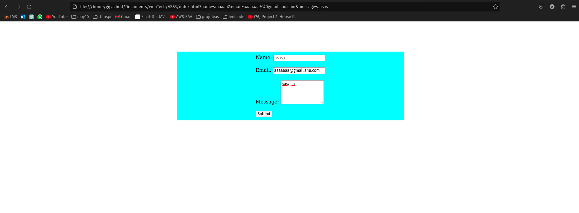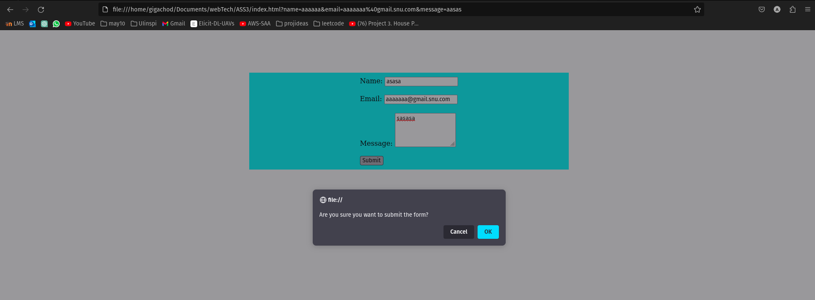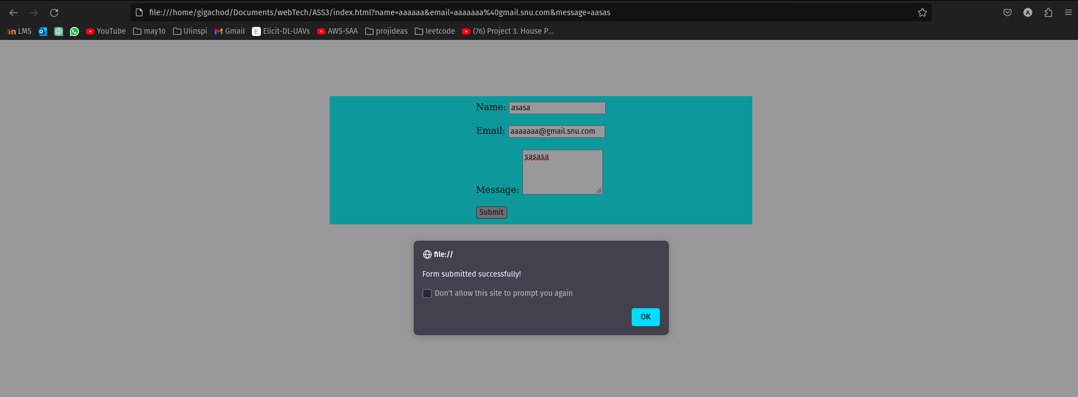

**Result:**

Therefore, created a form and validated it using javascript.